*Saving the Great-Barrier Reef with ML and IoT*

Prof. Suhas Bhise

*Vishwakarma Institute of Technology, Pune*

[suhas.bhise@vit.edu](mailto:suhas.bhise@vit.edu)

Vijay Kumar Singh

*Vishwakarma Institute of Technology, Pune*

[vijay.singh20@vit.edu](mailto:vijay.singh20@vit.edu)

Vishal Ramchandra Phonde

*Vishwakarma Institute of Technology, Pune*

[vishal.phonde20@vit.edu](mailto:vishal.phonde20@vit.edu)

Vishal Premkumar Gurudasani

*Vishwakarma Institute of Technology, Pune*

[vishal.gurudasani20@vit.edu](mailto:vishal.gurudasani20@vit.edu)

**Abstract**

In order to suppress Crown-of-Thorn Starfish (COTS) outbreaks, which are a significant contributor to coral loss on the Great Barrier Reef (GBR), extensive surveillance and control measures are in place. COTS populations to levels that are environmentally sound. To promote research on machine learning and AI-driven technologies to better the identification, monitoring, and management of COTS populations at reef size, we release a large-scale, annotated underwater image collection from a COTS out-break location on the GBR. The dataset is made available and hosted in a Kaggle competition that sets the goal of COTS detection from these underwater photographs for the machine learning community worldwide.

Keywords: Machine Learning, AI, COTS Dataset.

**Introduction**

The crown-of-thorns starfish, or COTS, is a predator of coral in the wild. Corals are however consumed when populations reach epidemic levels (about 15 starfish per hectare).

rapidly than they can develop with COTS. During an outbreak, crown-of-thorns starfish can consume up to 90% of the living coral tissue in a reef. The pressure already put on the reef by issues like bleaching and climate change is increased by this. To better comprehend and keep track of COTS outbreaks, a huge amount of information and resources have been provided by numerous environmental organizations, academic institutions, governmental organizations, and members of the general public. On the other hand, fresh outbreaks come along in cycles of 1 to 15 years, making it difficult to identify the root reasons or even manage their numbers. According to decades of studies on the Great Barrier Reef, there are many causes for this, including ocean "stressors" including increases in ocean nutrients caused by coastal and agricultural runoff into the ocean and a loss of predators owing to overfishing. In this study, I used the You Only Live Once algorithm, which is employed in embedded systems and mobile devices, to train and assess the COTS detection model (YOLOv5 tiny version 6). Its central component is a cutting-edge convolutional neural network (CNN), with the necessary configuration that parameters were optimized. Additionally, We used cutting-edge data augmentation techniques to improve the dataset's quality and size from "The CSIRO Crown-of-Thorn Starfish Detection Dataset."

Literature Review

1]Crown-of-Thorn Starfish (COTS) outbreaks are a major cause of coral loss on the Great Barrier Reef. We release a large-scale, annotated underwater image dataset from a COTS outbreak area on the GBR to encourage research on Machine Learning. The dataset is hosted in a Kaggle competition that challenges the international Machine Learning community with the task of COTS detection from these underwater images.

2]The YOLOv5 object detector can be modified to improve its performance in detecting smaller objects, with a particular application in autonomous racing. In doing so, we propose a series of models at different scales, which we name 'YOLO-Z', and which display an improvement of up to 6.9% in map. This could increase the amount of contextual information available to such systems.

3]Crown-of-thorns. starfish may devour up to 90% of a reef's living coral tissue during an epidemic. When populations reach epidemic levels (about 15 starfish per hectare), corals are eaten quicker by COTS than they can develop. New outbreaks of COTS occur in 1–15-year cycles, making it impossible to pinpoint exact causes or even keep its numbers under control.

4]The Crown-of-thorns starfish (COTS) is one of the few main factors that is responsible for coral loss on the great barrier reef. Detecting these small creatures in a complex underwater environment can be a very difficult task. The best performing models are coming from the YOLOv5 architecture and with the use of WBF ensemble method.

5]The Hadoop software stack consists of an extensible MapReduce execution engine, pluggable distributed storage engines, and a range of procedural to declarative interfaces. Most practitioners of big data analytics lack the expertise to tune the system to get good performance. We introduce Starfish, a self-tuning system for big data analytics that provides good performance automatically.

6]Analyzing texture recognition in underwater images could have implications for marine pest population control such as Crown-Of-Thorns Starfish (COTS). This research applies and extends the use of Local Binary Patterns (LBP) as a method for texture-based identification of COTS from surveyimages. The performance and accuracy of the algorithms are evaluated on a data set taken on the Great Barrier Reef.

Component Used

Python, Matplotlib, OpenCV, Numpy,pandas,Servo Motor,ESP32,ESP8266.

**Methodology**

Several model architectures will be trained, tested, and evaluated by their performance for the project “Saving The Great Barrier Reef”. Additionally, an ensemble method that aggregates the predicted bounding boxes of the models was used to test the models.

These architectures are based on convolutional neural networks, like

OpenCV.

OpenCV

OpenCV is the huge open-source library for the computer vision, machine learning, and image processing and now it plays a major role in real-time operation which is very important in today’s systems. By using it, one can process images and videos to identify objects, faces, or even handwriting of a human. When it integrated with various libraries, such as NumPy, python can process the OpenCV array structure for analysis. To Identify image pattern and its various features we use vector space and perform mathematical operations on these features. The first OpenCV version was 1.0. OpenCV is released under a BSD license and hence it’s free for both

academic and commercial use. It has C++, C, Python and Java interfaces and supports Windows, Linux, Mac OS, iOS, and Android. When OpenCV was designed the focus was real-time applications for computational efficiency. All things are written in optimized C/C++ to take advantage of multi-core processing.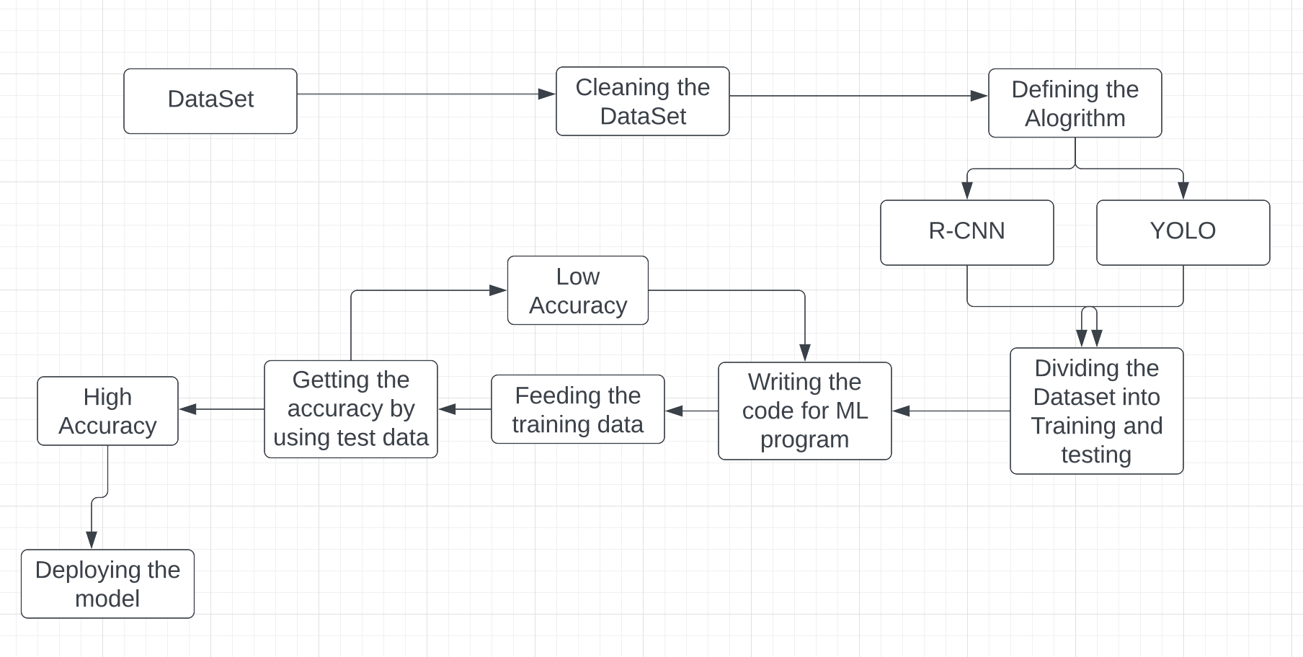

**Result**

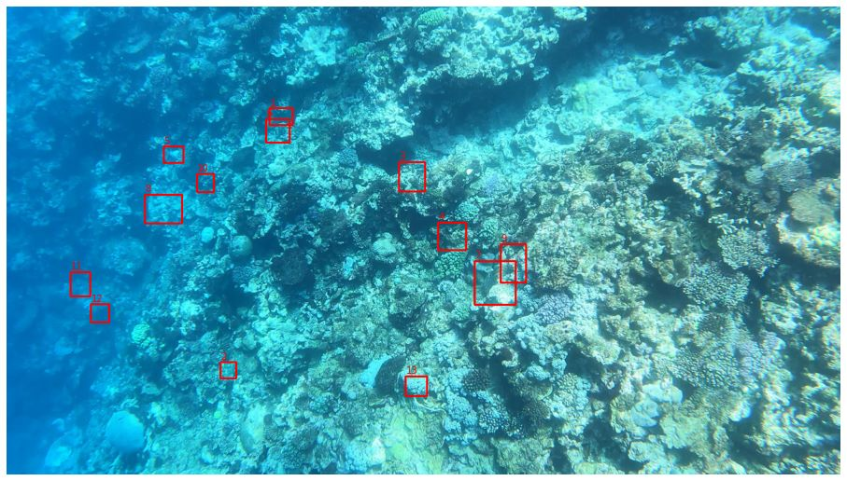

**Conclusion**

In our project we have train a machine learning model using OpenCV to detect the crown starfish and from our observation we can conclude that it gives the accuracy around 80%. We also attach robot arm so if our module detects a starfish, it can attack it. Above further advancement we can develop more advance robot arm with better detection accuracy.

**References**

[1] Liu, Jiajun & Kusy, Brano & Marchant, Ross & Do, Brendan & Merz, Torsten & Crosswell, Joey & Steven, Andy & Heaney, Nic & Richter, Karl & Tychsen-Smith, Lachlan & Ahmed Aristizabal, David & Armin, Ali & Carlin, Geoffrey & Babcock, Russ & Moghadam, Peyman & Smith, Daniel & Davis, Tim & Moujahid, Kemal & Wicke, Martin & Malpani, Megha. (2021). The CSIRO Crown-of-Thorn Starfish Detection Dataset.

[2] Benjumea, Aduen & Teeti, Izzeddin & Cuzzolin, Fabio & Bradley, Andrew. (2021). YOLO-Z: Improving small object detection in YOLO v5 for autonomous vehicles.

[3] Nguyen Quoc Toan. Detrimental Starfish Detection on Embedded System: A Case Study of YOLOv5 Deep Learning Algorithm and TensorFlow Lite framework. Publisher- Journal of Computer Science Institute.

[4] Blomvliet, Marc. (2022). Protect the Great Barrier Reef Identifying starfish in real-time by an object detection model. 10.13140/RG.2.2.12867.27689.

[5] Westcott, David & Fletcher, Cameron & Kroon, Frederieke & Babcock, R. & Plaganyi, Eva & Pratchett, Morgan & Bonin, Mary. (2020). Relative efficacy of three approaches to mitigate Crown-of-Thorns Starfish outbreaks on Australia's Great Barrier Reef. Scientific reports. 10. 12594. 10.1038/s41598-020-69466-1.

[6] Herodotou, Herodotos & Lim, Harold & Luo, Gang & Borisov, Nedyalko & Dong, Liang & Cetin, Fatma & Babu, Shivnath. (2011). Starfish: A Self-tuning System for Big Data Analytics. CIDR 2011 - 5th Biennial Conference on Innovative Data Systems Research, Conference Proceedings. 261-272.

[7] Clement, Ryan & Dunbabin, Matthew & Wyeth, Gordon. (2012). Toward Robust Image Detection of Crown-of-Thorns Starfish f or Autonomous Population Monitoring. Proceedings of the 2005 Australasian Conference on Robotics and Automation, ACRA 2005.

[8] https://www.kaggle.com/datasets/alexteboul/binary-cropped-crown-of-thorns-dataset/download?datasetVersionNumber=1